Port Questionnaire

*(to be filled out per ship per call!)*

|  |  |
| --- | --- |
| **Ship** | MS ALBATROS |
| **Port City** | CASTRIES ST LUCIA |
| **Date** | JAN 02, 2019 |
| **Arrival time** | 08 HRS |
| **Departure time** | 18 HRS |
| **Public Holiday** | Yes:  No: |
| **Name & Address of Port** | POINT SERAPHINE ,PORT CASTRIES, ST LUCIA |
| **Name/No of expected Berth** | POINT SERAPHINE Berth 2 |

## Port Facilities

|  |  |
| --- | --- |
| Bank | Yes:  No: |
| Post Office | Yes: YES No: ☐ |
| Shops | Yes: YES No: ☐ |
| Tourist Information | Yes: YES No: ☐ |
| Telephone | 1-758-457-3425 |
| Wi-Fi | Yes: YES No: ☐ FOC: ☐ |
| Taxi | Yes: YES No: ☐  Phone: 1-758-584-9252 |
| Bus station | Yes:  No: |
| Hop On / Hop Off | Yes: ☐ No: NO☐ |

## General Port Information

|  |  |
| --- | --- |
| * Distance to port exit * Is it allowed to walk inside the port?   + If no, is there a shuttle service? * Is it allowed to ride a bicycle inside the port area?   + If not, can they be carried in the shuttle? * Shuttle Service to the city center * Is it allowed to bring any kind of food ashore? | * 10 MINUTES WALK * Yes: No: * Yes: No:  FOC: * Yes: No: * Yes: No: * Yes: No:  FOC: * Yes: No: |

## Country Information

|  |  |
| --- | --- |
| Currency | US DOLLARS |
| Accepted Payements:   * Only local currency: * Cash in US $ * Cash in € * Credit Cards * Maestro / Debit Card | * Yes: ☐ No: NO☐ * Yes: ☐Yes No: ☐ * Yes: ☐ Yes No: ☐ * Yes: ☐Yes No: ☐ * Yes: ☐Yes No: ☐ |
| Postage   * Postcard * letter | * US1.00 * US $1.00 or less |
| Typical Souvenir | Hand woven baskets, Place mats and coasters, Batik placemats and table covers, hand painted ceramics |

## Distances

|  |  |  |  |
| --- | --- | --- | --- |
| * City Center * Next recommendable beach * Airport * Main Station | * .75 * 1 * 1 * None | km:  km:  km:  km: | Taxi fare: US$4.00  Taxi fare: US $5.00  Taxi fare: US $5.00  Taxi fare: N/A |

## General Information

|  |  |  |
| --- | --- | --- |
|  | Where: | Business/Opening Hours: |
| Tourist Information | * At Point Seraphine in the Cruise Ship Terminal | * 9:00 AM TO 4:30PM |
| Post Office | * On Bridge Street in the City | * 8:00 TO 4:30 PM |
| Shopping | * At Point Seraphine in the Cruise Ship Terminal | * 9:00 AM TO 5:00 PM |
| Museums | * None | * N/A |
| Restaurants | * At Point Seraphine in the Cruise Ship Terminal | * 9:00 AM TO 5:00 PM |
| Places of interest: | * The Derek Walcott Square, The Catholic Basilica, The C entral Library | * 8:00 am to 5:00 pm |
| Shuttle services FOC | * Taxi | * 1-758-584-9252 TAXI SERVICE |

## Special Remarks

Castries, the principal City of St. Lucia, is the seat of government and is situated at the eastern extremity of the beautiful harbour which bears its name. In maritime circles it is better known as Port Castries. It was originally called “Carenage” or petit Cul-de-Sac because it was a land-locked harbour used for careening ships while under repairs, and in the days of sail when wind-jammers roamed the Caribbean, this safe service earned for Port Castries the descriptive Virgilian legend: “Statio Haud Malefida Carinis”. This is as true today as it ever was: a safe anchorage for ships.

Point Setaphine, well known throughout the Caribbean, is home to the cruise dedicated berths on the Island. It is located within walking distance of the city of Castries, and consists of a number of shops offering a range of both locally made and international products. Water taxis are also available from Pointe Seraphine to La Place Carenage.

La Place Carenage Duty Free Shopping Mall is the home to many cruise ships and passengers, but La Place Carenage also boasts a variety of shopping and is home to the ever popular Tea Time Jazz. Situated in the heart of Castries, La Place Carenage is a modern duty free shopping complex with a historic French colonial style, that offers authentic designer labels, brand named goods, dazzling jewelry, local arts and crafts, heady local liquors and fragrant island spices, linens, crystal and perfumes, just to name a few.

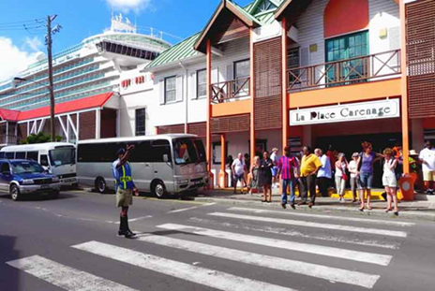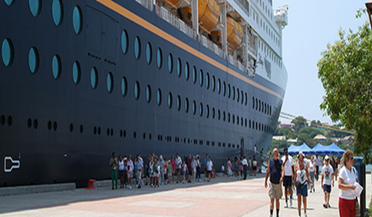

La Place Carenage Point Seraphine Cruise Terminal

[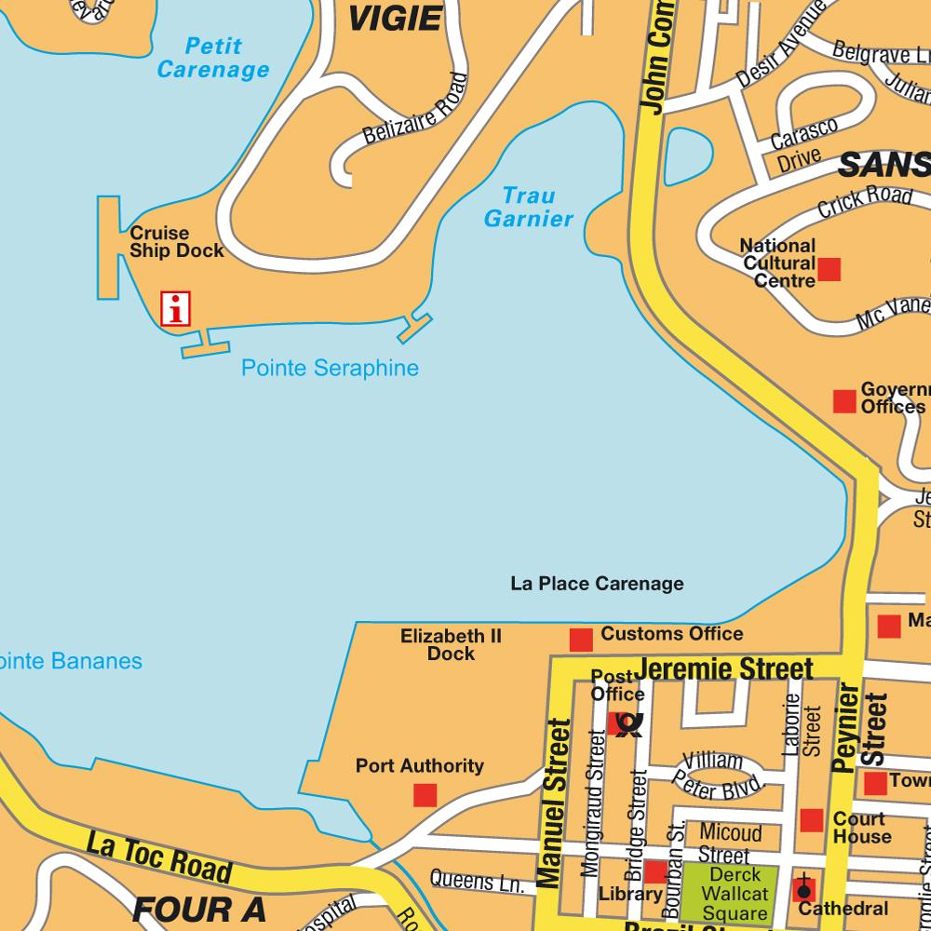](http://www.google.com/url?sa=i&rct=j&q=&esrc=s&source=images&cd=&cad=rja&uact=8&ved=2ahUKEwjm1LSWmc7bAhWMu1MKHUKoBtkQjRx6BAgBEAU&url=http://www.hot-map.com/us/castries&psig=AOvVaw1zv_qg5RMjYvqbac-AhuGE&ust=1528895351940558)

MAP OF CASTRIES

[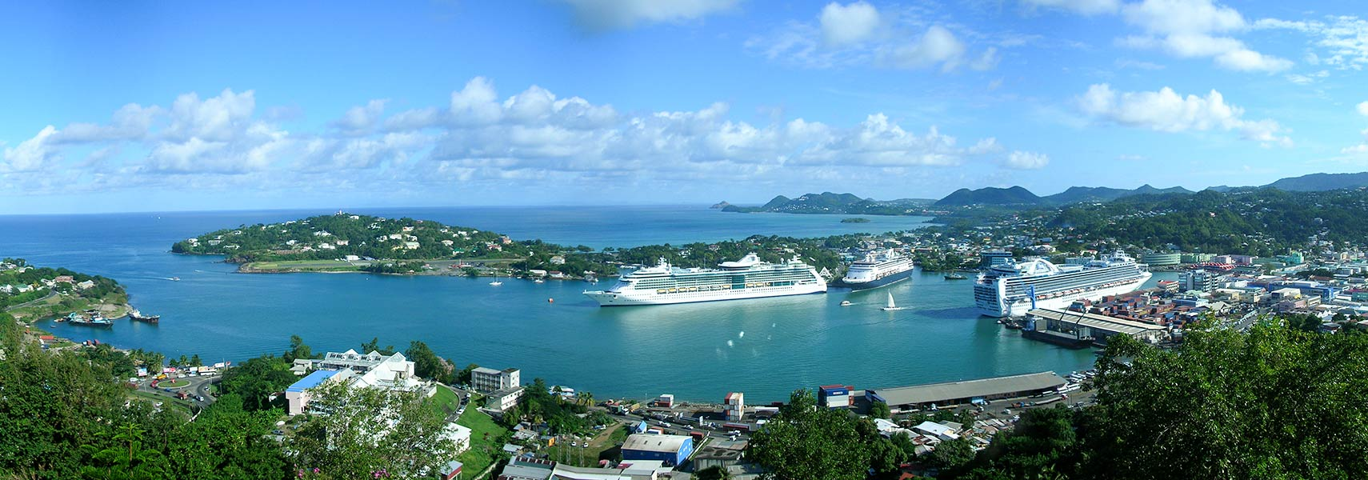](http://www.google.com/url?sa=i&rct=j&q=&esrc=s&source=images&cd=&ved=2ahUKEwiKyqq8m87bAhVD1lMKHZCTCO8QjRx6BAgBEAU&url=http://www.nationsonline.org/oneworld/map/google_map_Castries.htm&psig=AOvVaw1zv_qg5RMjYvqbac-AhuGE&ust=1528895351940558)

PORT CASTRIES